**PES UNIVERSITY**

**(Ring Road Campus)**

**DEPARTMENT OF**

**COMPUTER SCIENCE ENGINEERING**

**5th SEMESTER**

**SECTION – ‘D’**

**IOT [ UE19CS313] REPORT**

on

**“SMART CAR PARKING SYSTEM”**

**BY**

**DIVYANSHU SHARMA [PES1UG20CS806]**

**ABSTRACT**

Wireless sensor networks (WSNs) have attracted increasing attentions from both academic and industrial communities. It can be deployed in various kinds of environments to monitor and collect information. This paper aimed at developing an intelligent car parking system that is more cost effective and user friendly than the already existing systems. The first phase aimed at making cars detectable in the parking lot through the use of sensors, while the second phase aimed at communicating the collected data to the user remotely. The system was created and tested in two ten-lot parking lots (A and B), where it was tested physically in section A (lot A1), and in a simulation mode in both car park sections A and B. The project was highly successful attaining a 90% accuracy level, which is inside of the satisfactory levels of utilization.

**INTRODUCTION**

Technological advancements have led the advancement and prevalence of Wireless Sensor Networks (WSN) in many of man's activities. The WSN consists of numerous low-costing sensor nodes that are organized to establish an ad hoc network via a wireless communication module that is equipped on the nodes. The sensor nodes are equipped with different sensors, computation units, and storage parts to collect cooperatively, process and provide sensory data for localization and surveillance. WSN technology has been applied in both civil and military applications such as intelligent buildings, smart homes among others. This paper describes the design and implementation of a WSN used in creating an intelligent car park management system based on low-cost wireless sensors. The intelligent car parking system can detect the car when parked in the parking lot and communicate with a server using Xbee zigbee (Series 2) to display the result on the webpage and board sign section that are placed between car park sections and is user-friendly to enhance the convenience of car parking. The WSN project was divided into two phases; the first phase involved making a car detectable to other cars while parked in the parking lot. This was achieved by placing a sensor right above the car at a height of two meters and the second sensor in front of the car with a fifty-centimeter ground clearance. The second phase involved inducting & implementing wireless parameters to the experiment to enable the system to communicate the occupancy of the parking sections to the user in the control room. The system will allow parking administrators and managers to get real-time information about the parking field thereby promoting easy and enhanced parking management.

**REQUIREMENT ANALYSIS**

In this section, we discuss the requirements of designing a wireless sensor network for a smart car park system. Although the conventional requirements of a car park system can be easily satisfied, we still need to address more challenging issues by taking advantages of wireless sensor network. In the following, we list some important requirements of a car parking system and then analyze the feasibility from the viewpoint of wireless sensor networks. The common goal for all car parks is to attract more drivers to use their facilities from the business aspect. Thus, their basic facilities are required to fulfil the following conventional requirements:

1. The location of the car park should be easy to find in the street network.
2. The entrance of the car park should be easy to discover.
3. The number of parking lots should be abundance and a parking lot should obtain a large space enough to park a car in.
4. Easy to exit and to re-enter on foot. However, a smart car park system should provide more convenience and automation to both the business and customers.

**It should also satisfy the following requirements:**

1. The system should provide plenty of informative instructions or guidelines to help drivers to find an available parking lot.
2. The system should provide powerful functions to facilitate administrators and managers to manage a car park. In accordance with the above requirements, a smart car park system should minimize human operations and supervisions, so as to reduce the cost of manpower and the lost from human mistake and to enhance efficiency. Also, the car park system is required to provide higher accuracy, robustness, and flexibility in operations, more convenience to customers, lower cost of operating and maintaining overall system.

**AN OVERVIEW OF OUR SYSTEM**

In this section, we describe the design & work flow of our smart car park system. First, we will introduce the hardware components employed in our system. Second, we will discuss the design and infrastructure of the system based on the wireless sensor network.

**Table 1: List of Components that been used for smart car park system.**

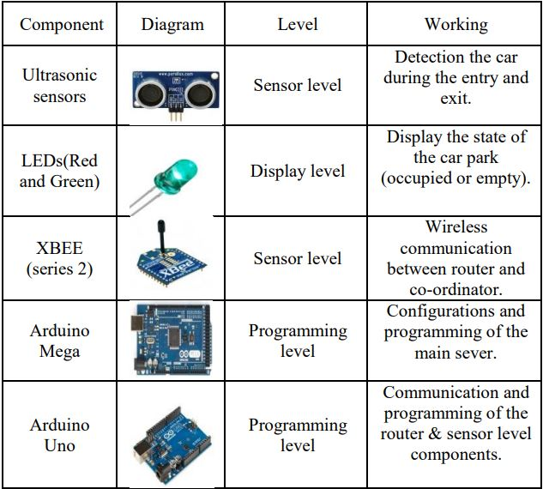

**The reason why we choose these components:**

Ultrasonic sensors are cost effective and come with better accuracy. Xbee radios can communicate wirelessly between each other and it can transmit signal over large distance (indoor capacity 40m and outdoor capacity 120m). Arduino Mega module can work as a server, it can be useful for maintaining web page and has large store capacity. Arduino Uno module can work as a router, it has better memory management and it's compatible with XBee radio. LED can be visible from every direction and it is power efficient

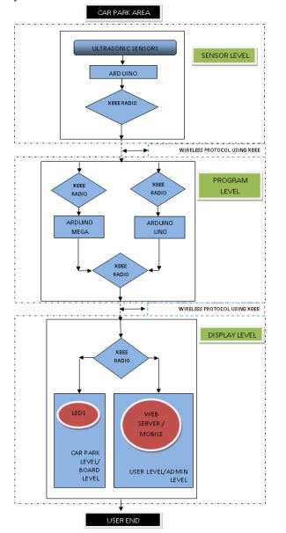**Figure 2: System Architecture of smart car park.**

The above block diagram describes system architecture and functionality. The system signifies three major parts, Sensor level, Program level and Display level. Sensor level circuit is made up of two ultrasonic sensors, Arduino Uno module, XBee radio and two LEDs (Red and Green). Programming level circuit consists of three Xbee radios, Arduino Mega module and Arduino Uno module. Display level circuit is made up of Xbee radio, four LEDs (two for each section A and B), Web page and smart phone. When a car arrives in parking lot, it is sensed by ultrasonic sensor which is one of the components of the sensor level. After getting data from the ultrasonic sensor, Arduino Uno module processes the data and sends it to Programming level through XBee radio. Data contains information about parking lot status. Once Programming level circuit receives parking lot status, it carries out corresponding changes in web page, mobile, section LEDs and respective parking lot LED.

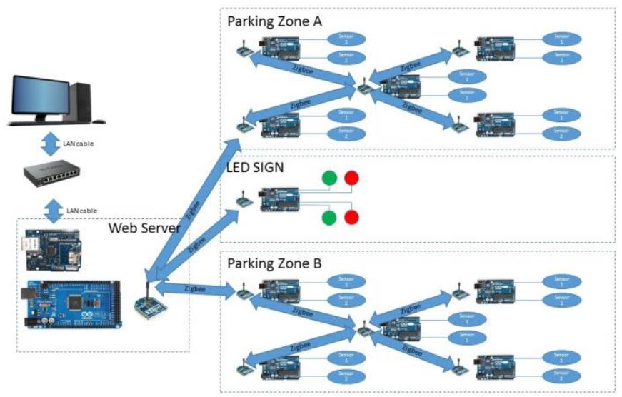

**Figure 3: System circuit Diagram.**

Figure 3 shows the overview of the whole system design and system has been divided into two phases:

1. Sensor detection on car park lot.
2. Wireless communication using Xbee radio and webpage. The first phase was to make the car detectable. Thus, two ultrasonic sensors were placed on the parking lot. The first sensor was placed above the car at a height of two meters from the ground, whereas the second was placed in front of the car with a fifty-centimeter ground clearance. The first phase was successful with the two sensors detecting the vehicle within proximity of less than 1.55 meters from each sensor as shown in figure 3.

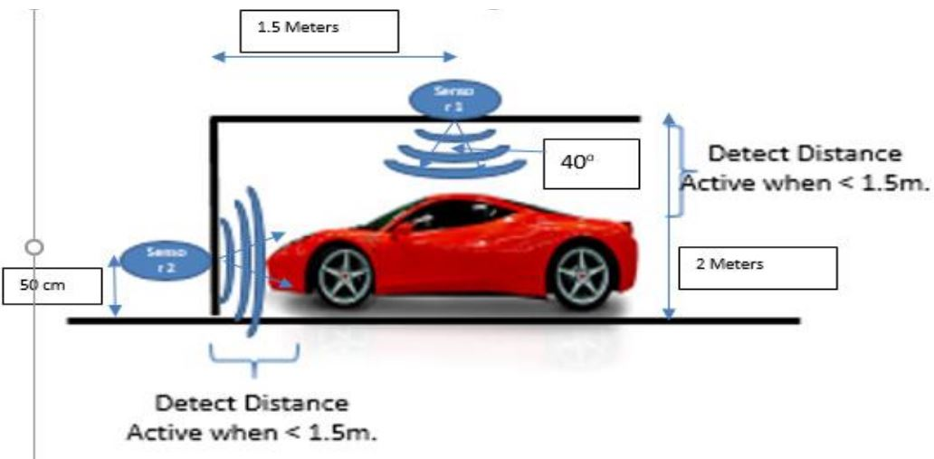

**Figure 4: Sensor Installation**

In the second phase, Arduino Mega module, Ethernet module, and XBee radio were used for the establishment of the web server circuit. The Ethernet module was interfaced above the Arduino Mega module and an Xbee radio placed above it. The Web server program uploaded in the Arduino Mega module, Ethernet module helped to get connected with the network and XBee radio communication helped to initialize between Field circuit, LED circuit and Web Server. Further, two LEDs, one red and the other green were connected to the module. Pins A0 and A1 were connected to the red and green LED respectively.

When the ultrasonic sensor received the signal from the from Arduino Uno module, it emitted sonic waves which were then reflected by the object and sensed by the sensor. The time between transmitting and receiving sonic waves was proportional to the distance between the object and the sensor, whereby longer time was taken when the distance between the sensor and the object were larger. The Ultrasonic sensor then sends a timing pulse to the Arduino Uno module which would be equivalent to the distance and the program uploaded in the module processes the time received from the sensor. If the data showed that the distance between both sensors is greater than 150 centimetres, the conditions satisfied the car parking condition; then the module sends the signal to the server specifying that the parking lot is empty, and makes the red LED OFF and the green LED ON. If the distances received from the both sensors are below 150 cm, modules send signal to the server which specifies that parking lot is occupied, and it makes the red LED ON and the green LED OFF, figure 4 shown sensor node process.

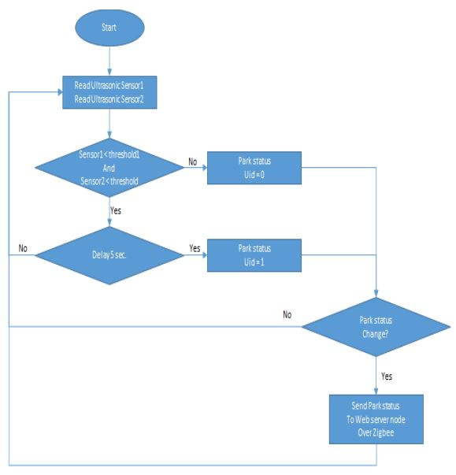

**Figure 5: Sensor node circuit flow chart**

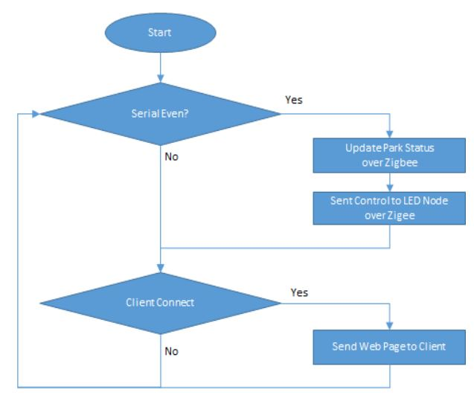The web server node program used the two ultrasonic sensors for automatic updating. The event for car detection was when both sensors had the status=1, while the event status=0, there was no car detected. The web server was programmed to recognize these two events and change the parking status automatically via the Zigbee. When the serial even=1 (car detected) or serial even=0 (no car detected), the web server recognized the event and updated the car park status over the Zigbee. The web page displayed that event as occupied (or not), using the red and **green LED respectively, as figure 5 explained the process of web-server.**

**Figure 6: Web server flow chart.**

**RESULT OF THE EXPERIMENT**

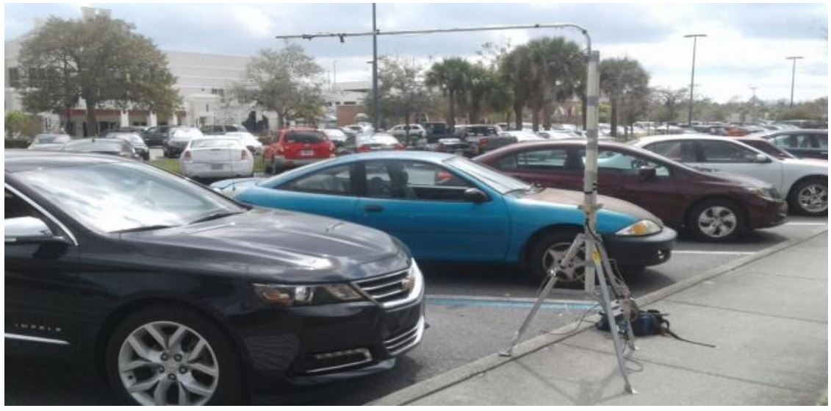The smart car parking system is built for real-life applications. Thus, quality and consistency are mandatory. Thus, we carried out some testing experiments using the prototype system to evaluate its dependability. The test area consisted of two parking areas of ten lots each divided into section A and B. However; equipment was only installed in parking lot A1 where the physical testing was carried. It was not possible to test the result physically for both lots: A1 & B1, hence for this project we took the help of the simulation tool (XCTU) to demonstrate the occupancy of the car park A1 and B1

**Figure 7: showing the physical testing on car park lot**

All observations were divided into two events: Event1: Car not in the car parking lot Event 2: Car in the car parking lot

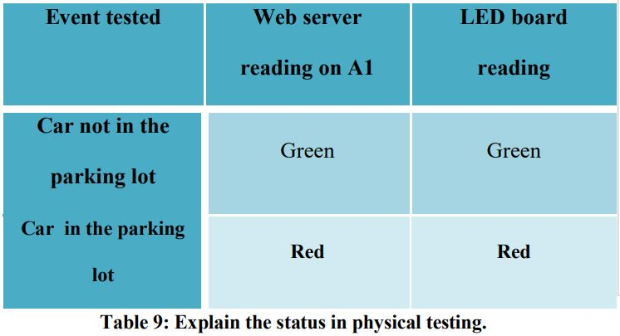

Since the equipment was only installed only on one parking lot, we simulated the results for the car park for the two sections (A and B) and each section has five car park lot (from A1, A2 …, A5) as shown in table 3.

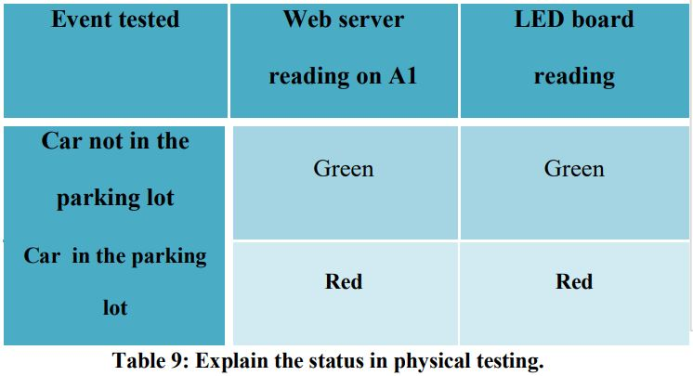

For simulation of two car parks simultaneously we used XCTU software. To simulate this setting we initialize three routers for section A1, section B1 and LED board, coordinating with one coordinator which is connected to the server. Each section we have two LEDs, green and red LEDs representing availability of the parking lot. For LED board we have used four LEDs, two LEDs for each section

The ultrasonic sensors are used for measuring the distance of detected objects. The maximum detection capacity of the sensor is 3.15meters. The sensors detect the object if within the range of 3.15meters. The sensors detection can be modified with help of the code. For the particular application like the car park, we need restrict our distance to the 1.2 meters for both the sensors. Figure 12 characterizes the detection pattern by the sensors with regards to the distance. From the graph it can be seen that the sensors detect the object till the distance of 1.2m as desired, but as distance increases beyond 1.2 meters up to 1.5 meters, the sensors behaviour is unpredictable. The ultrasonic sensors sensed objects within the range of 3.2 meters; this was 80% accuracy thus an error of 20%. However, the use of the two sensors in system led us to the conclusion that the system was 90% accurate, which is within the acceptable levels of application.

**FUTURE WORK**

This concept can be applied to the techno-commercial application of the car park. In the future, we will consider the case with 200 car parks. In the experimentation, the 200 car parks will be divided into 4 sections each of 50 lots respectively. For each five lots, we will require one Arduino, ten sensors, and one XBee ZigBee (Series 2) module, reaching to 40 Arduino, 400 sensors and 40 XBee ZigBee modules for the whole experiment as it shown in figure 2. These will be coordinated with server Zigbee module to allow the administrator to see the availability of lots on display. This work can be extended to autonomous car parks where the display will be used to detect the availability of parking lots as well as accepting different payment methods. The system may be linked to smart phones through mobile apps to enable clients to reserve parking lots using their mobile phones. The system could also be connected to GPS systems to allow clients to search for empty parking lots in different parking areas remotely while driving thus saving them time

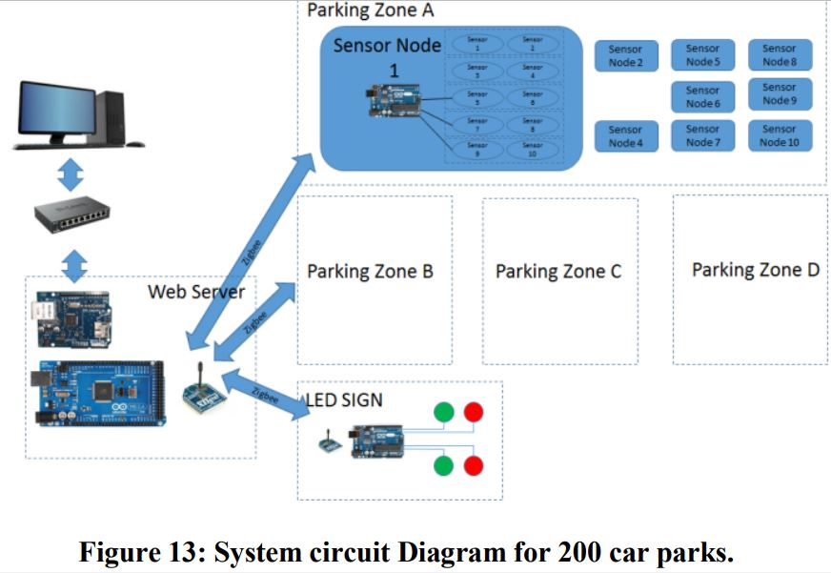

**Features:**

* Display at the entrance.
* Automatic slots assigning system.
* Tracking for the vehicles got parked.
* Saves the time by knowing the slots.
* Automatically keeps the entry records and exit records.
* Serves the customers by sitting inside the vehicle.
* 24*7 access.
* Easy to access.
* Reduced burden of manual slots arrangement team.
* Multiple automated functionality.
* Improving discipline and organized workings.

**CONCLUSION**

It is apparent that the demand for the smart car parking system will continue to increase in the upcoming years. Though the smart parking system already exists, our project is aimed at making the system more cost effective and user friendly thus increasing its adoption in the market. The project was successful & cost effective, user-friendly and had 90% accuracy. Future works will extend the system to administer 200 parking lots and incorporate other different technologies such as interlink with smart phones and GPS system to increase its dependability